DESCARTES.
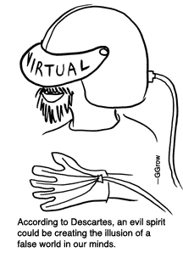
1) Descartes’ Place in the History of Philosophy
1.1. To what extent can Descartes be regarded as the father of modern philosophy?
1.2.What was the nature of the Cartesian revolution?
1.3. How much did Descartes take over from scholastic thought?
1.4. What role did he play in the emergence of science in the 17th century?
1.5. What was his relationship to the sceptics that preceded him?
(2) Scepticism and the Method of Doubt
2.1.What role does the Method of Doubt play in his philosophy?
2.2. How far can our senses be relied upon?
2.3. Could someone really be in doubt as to whether they are awake or dreaming?
2.4.What is the function of the evil demon hypothesis?
(3) The Cogito
3.1.Is the Cogito an intuition or a deduction?
3.2.Does it show that there must be some thinking thing (res cogitans)?
(4) Dualism
4.1.What is Descartes’ argument for the ‘real distinction’ between mind and matter?
4.2.What does he mean by a ‘thinking thing’?
4.3. Can one clearly and distinctly perceive minds as not having extension? If mind and body are metaphysically separate, how can they interact?
(5) God and the Cartesian Circle
5.1.What role does God play in Descartes’ system?
5.2. Is the so-called ‘Cartesian Circle’ vicious? Can the Cogito be regarded as establishing that whatever I clearly and distinctly perceive is true?
5.3.What is the ontological argument?
5.4.What is Descartes’ idea of God, and can there really be such an idea?
(6) Ideas, Reason
6.1.What does Descartes mean by ‘clear and distinct ideas’? How important are they within his system?
6.2. Are ideas innate?
6.3.How does Descartes define ‘thought’?
(7) Matter and Science
7.1.How does Descartes respond to scepticism about the external world?
7.2.How much does he think we can know about physical objects?
7.3.Does mathematical physics hold the key to understanding the world?
7.4.How much can science explain about human beings?
http://www-users.york.ac.uk/~mab505/teaching/emp/descarte/tops&qs.htm
