URL: http://www.breakingnewsenglish.com/0705/070517-suu-kyi.html
INTERNATIONAL CALLS TO RELEASE AUNG SAN SUU KYI.

A. WARM-UPS
1. CHAT: In pairs / groups, decide which of these topics or words from the article are most interesting and which are most boring.
campaigns / governments / pressure / arrests / freedom / parties / elections / temples / capital cities / stairs / cars / laws / rights / world leaders / poverty

2. HI. I’M LEADER: Imagine you are the leader of a non-democratic country. Talk to all the other “leaders” in the classroom about ruling a country.

3. DEMOCRACY: Which of these countries do you think are good democracies? Rank them on a scale of 10 (perfect democracy) to 1 (non-democratic).
- USA  - China  - Russia  - Saudi Arabia | - Zimbabwe  - Cuba  - United Kingdom  - your country _________________
4. HOUSE ARREST: In pairs / groups, talk about what it would be like to be under house arrest for four years. What would you do every day if you were not allowed outside your house?
5. QUICK DEBATE: Have this quick debate with your partner(s). Students A think democracy is important; students B think democracy is not important.

B. BEFORE READING / LISTENING
1. TRUE / FALSE: Look at the article’s headline and guess whether these sentences are true (T) or false (F):
a. | Many people have telephoned Myanmar’s leader about Ms. Suu Kyi. | T / F
b. | Fifty of Suu Kyi’s supporters wanting her release were arrested . | T / F
c. | There is an official date for the release of Aung Sun Suu Kyi. | T / F
d. | Aung San Suu Kyi’s political party won a general election in 1990. | T / F
e. | Suu Kyi’s supporters were arrested in a church in northern Yangon. | T / F
f. | They were taken away by the police in a very rough car. | T / F
g. | Nearly 60 ex-world heads signed a letter sent to Myanmar’s leader. | T / F
h. | Myanmar is near the bottom of the list of the world’s poor nations. | T / F
2. SYNONYM MATCH: Match the following synonyms from the article:
a. | campaign | made longer
b. | activists | furious
c. | release | released
d. | extended | campaigners
e. | detention | guarantee
f. | freed | fight
g. | violation | once
h. | secure | freedom
i. | angry | imprisonment
j. | formerly | abuse

3. PHRASE MATCH: Match the following phrases from the article (sometimes more than one combination is possible):
a. | a new campaign in Myanmar to | pressure
b. | authorities let the 15 supporters | known as Burma
c. | under growing | rights
d. | Suu Kyi has spent more than 11 | go a few hours later
e. | Her party won a general | north of the capital city Yangon
f. | a Buddhist temple | of the past 17 years in detention
g. | it was a violation of our civil | people in poverty
h. | help secure | free Aung San Suu Kyi
i. | Myanmar is keeping its | election in 1990
j. | The secretive country, formerly | the release of Suu Kyi

C. WHILE READING / LISTENING
GAP FILL: Put the words into the gaps in the text.

International calls to release Aung San Suu Kyi
There is a new ________ in Myanmar to free Aung San Suu Kyi, the opposition leader to the government. Police recently arrested 15 activists who were ________ the release of Suu Kyi. However, authorities ________ the 15 supporters go a few hours later. Experts believe Myanmar’s military government is under growing ________ to end Suu Kyi’s four-year-long house arrest. Although there is an ________ date of May 27 for her freedom, many believe this will be extended, unless more ________ is taken. Ms. Suu Kyi has spent more than 11 of the past 17 years in ________. Her party won a general election in 1990, but Myanmar’s junta refused to ________ the result. Instead, they imprisoned Suu Kyi and attacked members of her pro-democracy movement. |  | official  seeking  recognize  pressure  detention  campaign  action  let
The ________ of 15 supporters was arrested at a Buddhist temple north of the capital city Yangon. Myo Min Soe, a youth member of her party, was ________ those freed. He told reporters: "After our prayers, we climbed down the stairs of the temple and we were ________ taken away in a car…There is no rule of law and it was a violation of our civil ________." International pressure may also help secure the release of Suu Kyi. On Monday, 59 former world leaders signed a letter that was sent to Senior General Than Shwe, the leader of Myanmar. They ________ American Bill Clinton, Britain’s Margaret Thatcher, and Benazir Bhutto from Pakistan. They are angry that Myanmar is ________ its people in ________ and taking away their rights. The secretive country, ________ known as Burma, is among the poorest in the world. |  | rights  among  formerly  poverty  roughly  group  keeping  included

D. STUDENT SURVEY
Write five GOOD questions about FREEDOM in the table. Do this in pairs. Each student must write the questions on his / her own paper.
When you have finished, interview other students. Write down their answers.
 | STUDENT 1  _____________ | STUDENT 2  _____________ | STUDENT 3  _____________
Q.1.
Q.2.
Q.3.
Q.4.
Q.5.
- Now return to your original partner and share and talk about what you found out. Change partners often.
- Make mini-presentations to other groups on your findings.

E. HOMEWORK
1. INTERNET: Search the Internet and find more information about Myanmar. Talk about what you discover with your partner(s) in the next lesson.
2. NOBEL PRIZE WINNNERS: Make a poster about Aung San Suu Kyi. Show your poster to your class in the next lesson. Vote on the best one(s).
3. MAGAZINE ARTICLE: Write a magazine article Aung San Suu Kyi. Read what you wrote to your classmates in the next lesson. Which article was best and why?
4. LETTER: Write a letter to Aung San Suu Kyi. Ask her three questions about her pro-democracy movement and her house arrest. Give her three pieces of advice about her future. Read your letter to your partner(s) in your next lesson. Your partner(s) will answer your questions.
Recent information: BBC http://www.bbc.co.uk/news/magazine-19667956
22 September 2012. Aung San Suu Kyi: 'I have personal regrets'

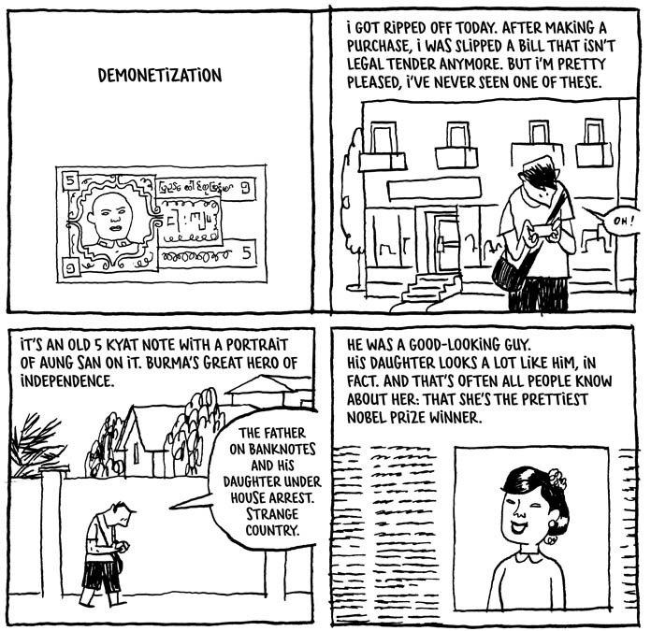
http://www.guydelisle.com/english/burma/page033_en.html

