ARKANGEL
- Arkangel, is a revolutionary child monitoring system, through a neural implant parents can monitor children's medical state, view her past and present vision and hearing, and avoid stressful stimuli.

Do you think there will be something like that in the near future?

- Read about Pocket Finder+, this is a real advert taken from Internet. Do you find it useful?

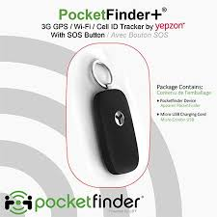

SAFETY IS KEY
PocketFinder+ provides an ideal way for families and caregivers to keep track of the people they love. Ideal for children heading to or from school or after school activities and seniors who value their independence. It’s all about having peace of mind when you’re not there with them.

Vehicle Trackers are always on, protecting one of your most valuable assets and those that ride inside.
PocketFinder Vehicle & PocketFinder+ help you know where they are and be alerted if they go too far – right from your App or computer! Breathe easier knowing those you love are safe!

- Why did the mother implant her doughter with Arkangel?
- Would you become tempted to use Arkangel with anyone (boyfriend/girlfriend, your own future children, etc.)? Why or why not?
- Would you live your house just like the protagonist does at the end? Why or why not?
- Don’t you think we should have dangerous criminals implanted? Why or why not?
- Do you think we are free or not? Write a composition and give reasons. (Minimal: 150 words.)
The following words could be useful:

Freedom, freedom of speech, freedom of assembly, freedom of thought and beliefs, free will, civil rights, slavery, chance, choose, options, alternative, moral responsibility, law, control, manipulation, prohibition, allow, forbid, punish, protest, compulsory.

